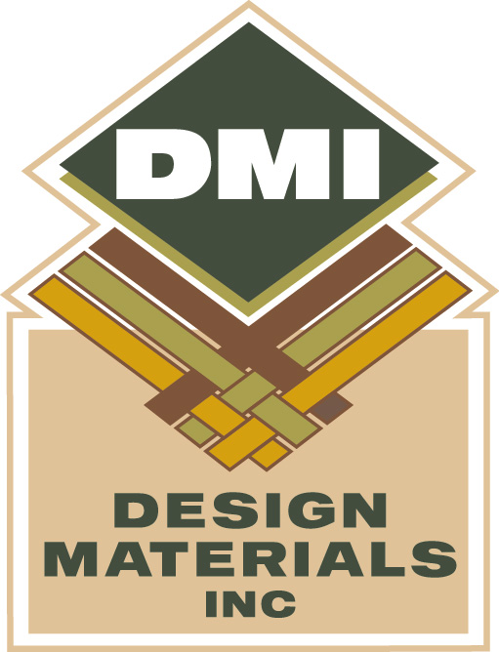
BISON

Technical Specifications

Pile material | 60% Pure New Wool 30% Goat Hair, 10% Nylon
Production process | Flatwoven
Warp and Weft | Polypropylene
Pile weight per sq. yard approx. | 40 oz.
Total weight per sq. yard | 89 oz
Total carpet height approx. | 3/16”
Backing | Action Back
Width | 13’2”
Fire Rating | Class A (ASTM E648-09a)
Origin | Denmark
Suitability | Heavy Domestic, Moderate-Heavy Contract, Class 32

90% All Natural pile, 10% Nylon is added to increase commercial durability

300g Felt Cushion backing adds comfort, durability and Acoustic benefits
Felt backing is produced from 98% PET Polyester, made from re-cycled Pop bottles.

Bison is certified ‘Gold’ under Eurofin testing for indoor air comfort.

Class 1 fire rating

Class 32 commercial performance rating

DESIGN MATERIALS, INC 241 S. 55TH ST. KANSAS CITY, KS 66106 www.dmifloors.com

